ASSIGNMENT SUBMISSION COVER SHEET
Student ID:
cse25-202

Bogolo Samoka
Student names:
cse25-202@thuto.bac.ac.bw
Student email:
2026
Cohort:
SCIS WMD_2026 A01
Assignment title:
28 October 2025
Date of submission:
BSC COMPUTER SYSTEMS ENGINEERING
Programme of study:
YEAR 1
Year of study:

Intellectual property statement
By checking the box below. I certify that this assignment is my own work and free from plagiarism. I understand that the assignment may be checked for plagiarism by electronic or other means and may be transferred and stored in a database for the purposes of data-matching to help detect plagiarism. The assignment has not previously been submitted for assessment in any other unit or to any other institution. I
have read and understood the Botswana Accountancy College plagiarism guidelines policy.
✓
Agree %% Signature: B.Samoka
Date:

WEBSITE PLANNING AND DOCUMENTATION

WEBSITE SPECIFICATION
🎯Website Objectives and goals
1. Knowledge & Awareness
- Clear, engaging information about Botswana’s animals — The Big Five, hence building a foundation of understanding before and during the safari which plays an important role in enriching the safari experience. By giving visitors background knowledge about these animals- their behaviours, habitats and importance within ecosystem or conversation status then tourists can understand and appreciate what they observe than simply viewing animals at a surface level.
- Understanding of animal behaviour, habitats, and conservation status. By learning how animals behave in their natural environments like their hunting patterns, social structures and daily routines. Additionally, understanding the conversation status of animals including whether they are threatened, raises awareness about the challenges wildlife faces such as poaching, habitat loss and climate change. This deeper level of understanding not only enhances appreciation but also encourages visitors to support conversation efforts and adopt more environmentally responsible attitudes during and after their safari experience.
2.Excitement & Inspiration
- A sense of wonder about Botswana’s wildlife that makes them eager to see it in person. Creating a sense of wonder about Botswana’s wildlife is key to capturing visitor’s interest and inspiring them to experience it firsthand. By showcasing the beauty, uniqueness and diversity of animals is an engaging way through storytelling, visuals or interactive content. As a result, this sense of wonder not only motivates visitors to explore Boswana’s natural environments but also helps create memorable expectations that enhance their overall experience.
- Beautiful high-quality visuals, interesting fun facts, and interactive features or elements that spark curiosity and helps capture attention and maintain user engagement. Images and videos of wildlife make the experience more vivid and appealing while fun facts provide quick, memorable pieces of information that are easy to understand. Interactive features like maps or clickable content encourage active participation rather than passive viewing and all together it makes learning more enjoyable and stimulate curiosity motivating users to explore more about Botswana’s wildlife.
3.Preparation & Confidence
- Practical insights: when and where to see animals, how to behave safely, what to expect on safari. Visitors receive helpful, experience-based guidance on the best times of day and seasons to spot different animals, as well as where there are most found. It also includes important safety advice like how to behave around wildlife, follow guide instructions and respect natural boundaries. Understanding what a typical safari involves such as long drives, changing weather and unpredictable animal sightings hence visitors can feel more relaxed and fully enjoy the experience.
- Answers to common animal-related questions so they feel ready for their trip. Clear responses to frequently asked questions like what animals they are likely to see, what to wear and how to act during encounters which help to remove confusion and uncertainty. This helps builds confidence allowing visitors to approach their safari with realistic expectations and a sense of readiness.
4.Respect & Responsibility
- Awareness of conservation efforts and how tourists can support them. (e.g. rhino conservation). Visitors are introduced to ongoing wildlife protection initiatives such as rhino conversation and shown simple ways to help like supporting eco-friendly tourism and respecting park rules. These builds a sense of responsibility towards preserving wildlife.
- Guidance on ethical wildlife viewing and respecting nature. Tourists are encouraged to observe animals respectfully by keeping a safe distance, avoiding disturbance and following guides instructions ensuring both their safety and the well being of the animals and environment.

🌍Target Audience
-International tourists planning safaris in Botswana.
-Wildlife enthusiasts who want to learn about The Big Five
-Students and educators seeking reliable information about African Wildlife.
-Conservation supporters interested in how Botswana protects these iconic species.

Audience Profile Analysis
Audience Segment | Likely Demographics | Technical Aptitude
International Tourists | Adults (25-65); High disposable income; Primary from North America, Europe and Asia | Moderate: Comfortable with travel booking platforms. Google Maps and social media but prefers intuitive, “one-click” navigation.
Wildlife Enthusiasts | All ages; Hobbyists; Frequent viewers of the nature documentaries (National Geographic, BBC Earth) | Low to Moderate: Focused on content rather than complexity; they value high-quality imagery and easy to read “fast facts”.
Students & Educators | Ages 12-25(Students) and 30-60 (Teachers and Professors); Global reach; Academic background. | High: Skilled at using search engines, citing digital sources and navigating structured data (tables, PDFs and deep-link citations)
Conservation Supporters | Adults (30+); Donors; Environmentally conscious; Often tech-savvy professionals. | Moderate to High: Interested in data-driven results; comfortable reading maps, impact reports and using secure donation portals.

Website Type
- Educational and informational Multimedia Portal

INFORMATION DESIGN AND TAXONOMY CREATION

Information Architecture (Site Map)

A sitemap represents the organizational architecture of my website, showing how different pages and sections are interconnected.

Level 1: Homepage
Index.html
This is the main entry point of the website, it contains:
-Website introduction
-Navigation menu
-Links to all main sections

Level 2 Pages (Main Navigation)
1. The Big Five
Overview gallery introducing the famous Botswana’s Big Five animals.
- African Lion

  - Common Name and Scientific Name
  - Profile
  - Conservation Status
- African Elephant
  - Common Name
  - Scientific Name
  - Profile
  - Conservation Status
- African Leopard
  - Common Name
  - Scientific Name
  - Profile
  - Conservation Status
  - Link: Sightings in Moremi
- African Buffalo
  - Common Name
  - Scientific Name
  - Profile
  - Conservation Status
- Rhinoceros
  - Common Name
Scientific Name
  - Profile
  - Conservation Status

2. Menu
- Habitats
- Diet
- Behaviours

3. Safari Planning
Provides travel preparation information for visitors.
Logistics
- Best time to visit Botswana
- Packing lists or suggestions for safari trips
Safety and Bush Rules
- Staying inside safari vehicles
- Campsite security
- Wildlife safety guidelines

4. Contact /Feedback and inquiries
- Local map
- Contact Form
- Social media links

Complete Website Structure (Site Map)
Homepage (index.html)
│
│── The Big Five
│ ├── Lion Profile
│ ├── Elephant Profile
│ ├── Leopard Profile
│ │ └── Sightings in Moremi
│ ├── Buffalo Profile
│ └── Rhinoceros Profile
│
│ ── Menu
│ ├── Habitats
│ ├── Diet
│ └ ── Behaviours
│── Safari Planning
│ ├── Logistics (Best time to visit, Packing Suggestions)
│ └── Safety and Bush Rules
│
└── Feedback & Inquiries
└── Contact Form

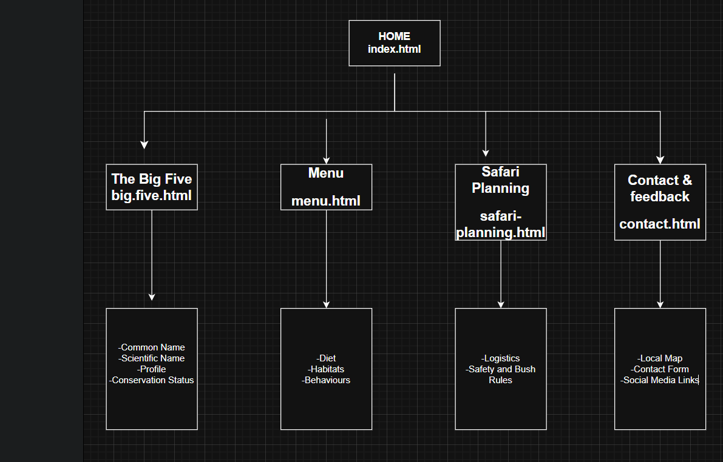

2. Storyboard Flowchart

Exploring The Big Five

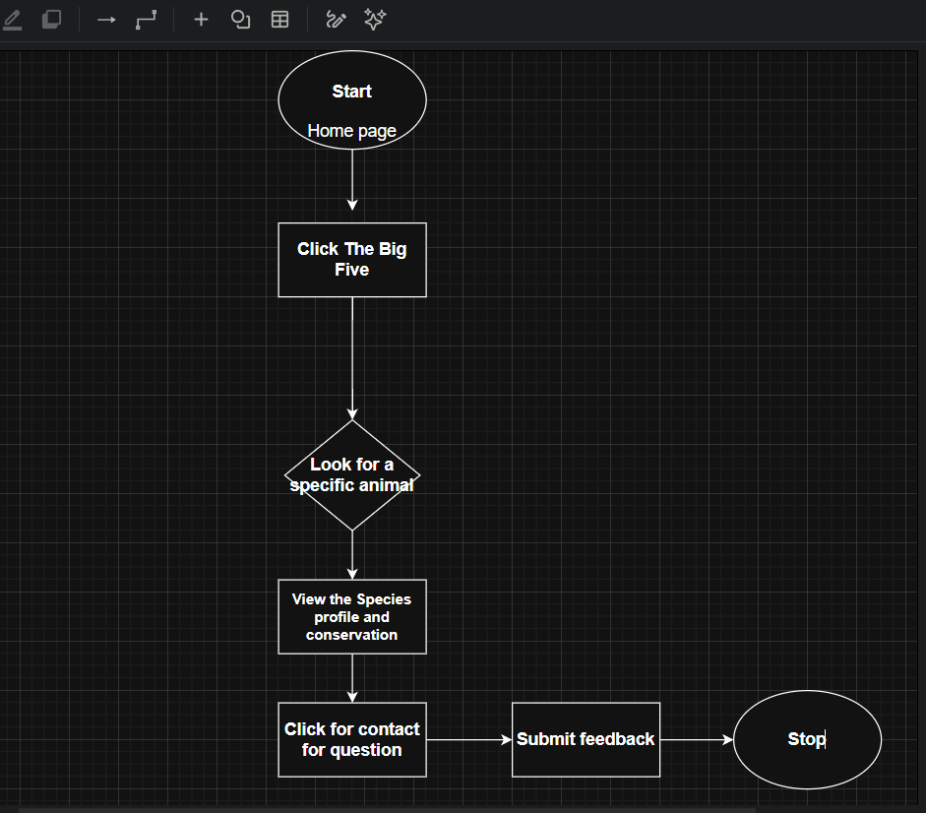

TECHNICAL BRIEF
1.Web Development Technologies
.HTML5: for structuring the website content (pages about each animal, information sections).
.CSS3: for styling, layout and responsive design to make the site visually appealing.
. JavaScript: to add interactivity such as image sliders.
2.Framework
. Bootstrap: for faster design and mobile friendly layouts.
3.Graphics and Design Tools
. Canva: for creating banners, infographics and visual content about animals.
. GIMP or Adobe Photoshop: for editing images and optimizing wildlife photos.
4.Development Tools
. Visual Studio Code: a code editor for writing and managing website files.
. Git and GitHub: for version control and hosting the website online.
5.Multimedia Resources
. High-quality images and videos of the Big Five (e.g. lion, elephant, leopard, rhino and buffalo).
6.Testing and Optimization Tools
. Google Chrome DevTools – for testing responsiveness and debugging.

PAGE TEMPLATE DESIGN
WIREFRAME
